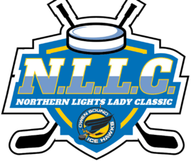

The Owen Sound Ice Hawks Present:

The Northern Lights Ladies Classic November 25-27, 2022

Cost: $1125 for U9-U13
Cost: $1225 for U15-U18

4 Game Guarantee

Divisions U9, U11, U13, U15, U18
Medallions and Banners to Division Finalists

For Tournament Information, please contact: darryl.ward@bgcdsb.org
For Association Information: www.owensoundgirlshockey.com

Payment options E-transfer and Cheque

